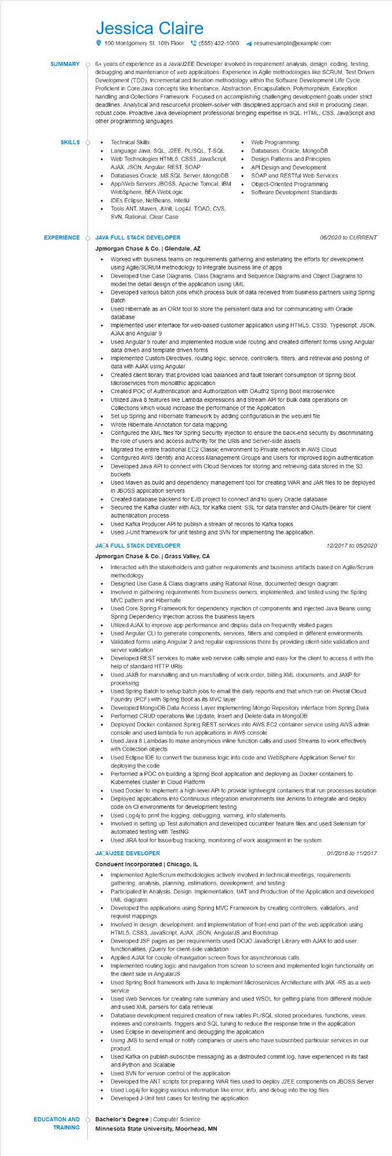
SUMMARY
Jessica Claire
100 Montgomery St. 10th Floor (555) 432-1000
resumesample@example.com
6+ years of experience as a Java/J2EE Developer involved in requirement analysis, design, coding, testing, debugging and maintenance of web applications. Experience in Agile methodologies like SCRUM, Test Driven Development (TDD), Incremental and Iteration methodology within the Software Development Life Cycle. Proficient in Core Java concepts like Inheritance, Abstraction, Encapsulation, Polymorphism, Exception handling and Collections Framework. Focused on accomplishing challenging development goals under strict deadlines. Analytical and resourceful problem-solver with disciplined approach and skill in producing clean, robust code. Proactive Java development professional bringing expertise in SQL, HTML, CSS, JavaScript and other programming languages.
SKILLS
•
•
•
Technical Skills:
Language Java, SQL, J2EE, PL/SQL, T-SQL Web Technologies HTML5, CSS3, JavaScript, AJAX, JSON, Angular, REST, SOAP
Databases Oracle, MS SQL Server, MongoDB App/Web Servers JBOSS, Apache Tomcat, IBM WebSphere, BEA WebLogic
IDES Eclipse, NetBeans, IntelliJ
Tools ANT, Maven, JUnit, Log4J, TOAD, CVS, SVN, Rational, Clear Case
•
Web Programming
Databases: Oracle, MongoDB Design Patterns and Principles
API Design and Development SOAP and RESTful Web Services Object-Oriented Programming Software Development Standards
EXPERIENCE O JAVA FULL STACK DEVELOPER
Jpmorgan Chase & Co. | Glendale, AZ
•
•
•
06/2020 to CURRENT
Worked with business teams on requirements gathering and estimating the efforts for development using Agile/SCRUM methodology to integrate business line of apps
Developed Use Case Diagrams, Class Diagrams and Sequence Diagrams and Object Diagrams to model the detail design of the application using UML
Developed various batch jobs which process bulk of data received from business partners using Spring Batch
Used Hibernate as an ORM tool to store the persistent data and for communicating with Oracle database
Implemented user interface for web-based customer application using HTML5, CSS3, Typescript, JSON, AJAX and Angular 9
• Used Angular 9 router and implemented module wide routing and created different forms using Angular data driven and template driven forms
Implemented Custom Directives, routing logic, service, controllers, filters, and retrieval and posting of data with AJAX using Angular
Created client library that provided load balanced and fault tolerant consumption of Spring Boot Microservices from monolithic application
Created POC of Authentication and Authorization with OAuth2 Spring Boot microservice
Utilized Java 8 features like Lambda expressions and Stream API for Bulk data operations on
Collections which would increase the performance of the Application
Set up Spring and Hibernate framework by adding configuration in the web.xml file
Wrote Hibernate Annotation for data mapping
Configured the XML files for Spring Security injection to ensure the back-end security by discriminating the role of users and access authority for the URIs and Server-side assets
• Migrated the entire traditional EC2 Classic environment to Private network in AWS Cloud Configured AWS Identity and Access Management Groups and Users for improved login authentication Developed Java API to connect with Cloud Services for storing and retrieving data stored in the S3 buckets
Used Maven as build and dependency management tool for creating WAR and JAR files to be deployed in JBOSS application servers
Created database backend for EJB project to connect and to query Oracle database
Secured the Kafka cluster with ACL for Kafka client, SSL for data transfer and OAuth-Bearer for client authentication process
• Used Kafka Producer API to publish a stream of records to Kafka topics
Used J-Unit framework for unit testing and SVN for implementing the application.
JACA FULL STACK DEVELOPER
Jpmorgan Chase & Co. | Grass Valley, CA
12/2017 to 05/2020
Interacted with the stakeholders and gather requirements and business artifacts based on Agile/Scrum methodology
Designed Use Case & Class diagrams using Rational Rose, documented design diagram
•
Involved in gathering requirements from business owners, implemented, and tested using the Spring MVC pattern and Hibernate
Used Core Spring Framework for dependency injection of components and injected Java Beans using Spring Dependency Injection across the business layers
Utilized AJAX to improve app performance and display data on frequently visited pages
Used Angular CLI to generate components, services, filters and compiled in different environments Validated forms using Angular 2 and regular expressions there by providing client-side validation and server validation
Developed REST services to make web service calls simple and easy for the client to access it with the help of standard HTTP URIs
Used JAXB for marshalling and un-marshalling of work order, billing XML documents, and JAXP for processing
Used Spring Batch to setup batch jobs to email the daily reports and that which run on Pivotal Cloud Foundry (PCF) with Spring Boot as its MVC layer
Developed MongoDB Data Access Layer implementing Mongo Repository interface from Spring Data
• Performed CRUD operations like Update, Insert and Delete data in MongoDB
•
Deployed Docker contained Spring REST services into AWS EC2 container service using AWS admin console and used lambda to run applications in AWS console
Used Java 8 Lambdas to make anonymous inline function calls and used Streams to work effectively with Collection objects
Used Eclipse IDE to convert the business logic into code and WebSphere Application Server for deploying the code
•
Performed a POC on building a Spring Boot application and deploying as Docker containers to Kubernetes cluster in Cloud Platform
Used Docker to implement a high-level API to provide lightweight containers that run processes isolation Deployed applications into Continuous integration environments like Jenkins to integrate and deploy code on Cl environments for development testing
Used Log4j to print the logging, debugging, warning, info statements
Involved in setting up Test automation and developed cucumber feature files and used Selenium for automated testing with TestNG
• Used JIRA tool for Issue/bug tracking, monitoring of work assignment in the system.
JACA/J2EE DEVELOPER
Conduent Incorporated | Chicago, IL
01/2016 to 11/2017
• Implemented Agile/Scrum methodologies actively involved in technical meetings, requirements gathering, analysis, planning, estimations, development, and testing
•
Participated in Analysis, Design, Implementation, UAT and Production of the Application and developed UML diagrams
Developed the applications using Spring MVC Framework by creating controllers, validators, and
request mappings
Involved in design, development, and implementation of front-end part of the web application using HTML5, CSS3, JavaScript, AJAX, JSON, AngularJS and Bootstrap
•
Developed JSF pages as per requirements used DOJO JavaScript Library with AJAX to add user functionalities, jQuery for client-side validation
Applied AJAX for couple of navigation screen flows for asynchronous calls
Implemented routing logic and navigation from screen to screen and implemented login functionality on the client side in AngularJS
Used Spring Boot framework with Java to implement Microservices Architecture with JAX-RS as a web
service
Used Web Services for creating rate summary and used WSDL for getting plans from different module and used XML parsers for data retrieval
Database development required creation of new tables PL/SQL stored procedures, functions, views, indexes and constraints, triggers and SQL tuning to reduce the response time in the application Used Eclipse in development and debugging the application
Using JMS to send email or notify companies or users who have subscribed particular services in our product
Used Kafka on publish-subscribe messaging as a distributed commit log, have experienced in its fast and Python and Scalable
•
Used SVN for version control of the application
Developed the ANT scripts for preparing WAR files used to deploy J2EE components on JBOSS Server
•
Used Log4j for logging various information like error, info, and debug into the log files
Developed J-Unit test cases for testing the application.
EDUCATION AND
Bachelor's Degree | Computer Science
TRAINING
Minnesota State University, Moorhead, MN

